Safe Water Project Proposal

The areas surrounding Escuintla, and the community of Col. Monterrey are not unlike the millions of communities across the world that lack access to safe water. The regional government lacks resources to tackle these problems and promote development which leaves the community with underdeveloped infrastructure. Children are constantly sick and missing school. Parents are trapped, desiring more for their families. Progress is stunted. Without help, there is little hope for this forgotten community.
Community: Col. Monterey Water & Sanitation Project
Region: Escuintla– Guatemala
GPS: S 14°'16.49.74”
E °90'46.9.74”
Number of People: 2250
Approx. Population: 3150
Total Budget: $ 59,851.64 USD
Contaminated water is a primary factor perpetuating the continuous poverty cycle plaguing this community. Currently, diarrheal illness, and cholera are prevalent in these communities and the residents know their current water source is contaminated.
From our assessment, we know that the majority of these communities obtains their household income as small business people or farm workers on large farms.. Their average household income is $250 USD per month. The community and local government have agreed to partner to provide the treatment system enclosure, install piping and help promote health and hygiene education. The community also understands that safe water fees will be collected for sustainable operation of the water treatment system.
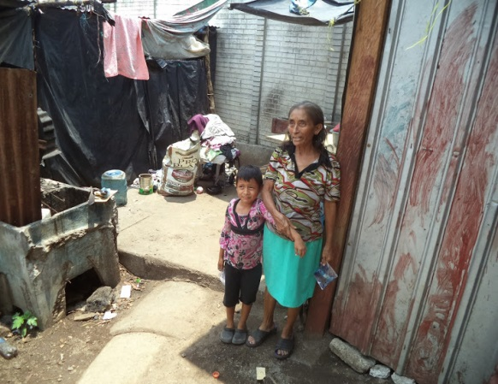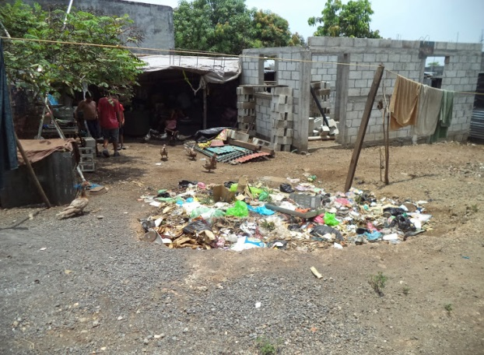
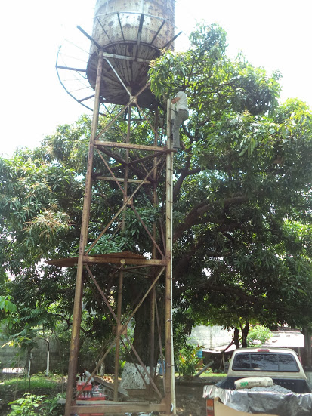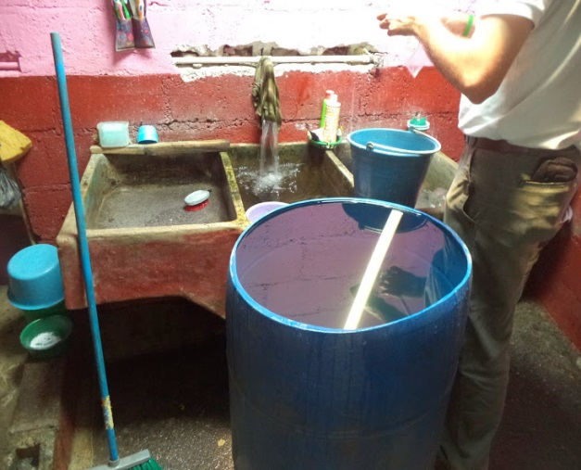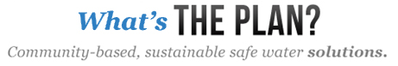
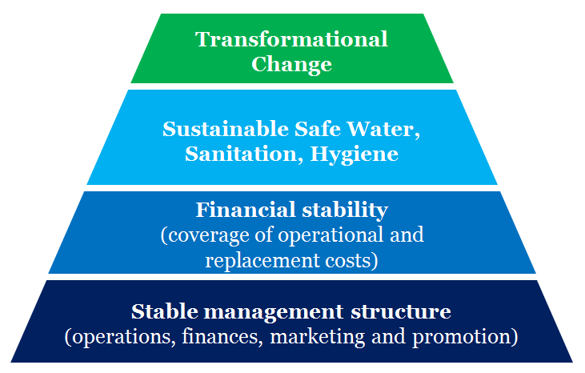
Community Managed Safe Water Project
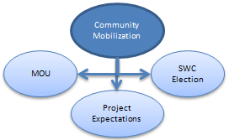
Water Missions Internationals (WMI) Community-Managed Safe Water Project Model facilitates transformational change in a community while attacking relational strongholds of the poverty cycle. This transformational change occurs through sustainable safe water, sanitation and hygiene education practices. The long-term sustainability of the safe water project is supported by a financial plan that accounts for ongoing operational costs and savings for equipment replacement costs. The foundation for all of these components is a stable management structure, which is embodied by the Safe Water Committee (SWC). The major focus of community development efforts in the community is concentrated on the development and support of this SWC. The WMI Community-Managed Model’s implementation process is specifically designed for community-led involvement, community equity contribution, and capacity building. WMI’s indigenous community development staff help support and guide the community through the process. There is no definite timetable for the process because each community’s path will be different.
Three Key Community Development Components
The Building Blocks of Success
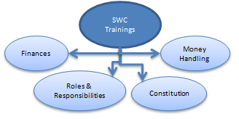
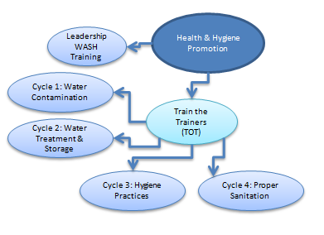
Community Mobilization: This community-led meeting is the formal introduction of Rotary and WMI to the entire community. The project objectives and the expectations of each party are discussed and documented in formal memorandum of understanding (MOU). The concept of the Safe Water Committee and member roles and responsibilities are also discussed so that the community can elect their own committee.
Safe Water Committee Trainings: Our Safe Water Committee training is broken into different sessions. The first session concentrates on roles and responsibilities and the formation of a constitution to establish the governing principles of the Safe Water Committee. The second session concentrates on the finical sustainability aspects of the ongoing operation, money handling and accountability. Committee readiness is evaluated during the final session.
Water, Sanitation and Hygiene Promotion: Leadership WASH (water, sanitation and hygiene) awareness training is conducted for all local leaders to further engage their support for the project. Community leaders and the SWC are tasked with identifying volunteer WASH promoters for the community. The Train the Trainers technique is used to equip WASH promoters to conduct (4) promotion cycles in the community: Cycle 1: Water Usage & Contamination, Cycle 2: Water Treatment & Storage, Cycle 3: Hygiene Practices, Cycle 4: Sanitation. During these cycles, WASH promoters visit each household in the community to discuss key messages.
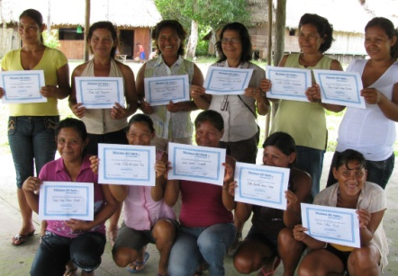
Community Provided Sweat Equity
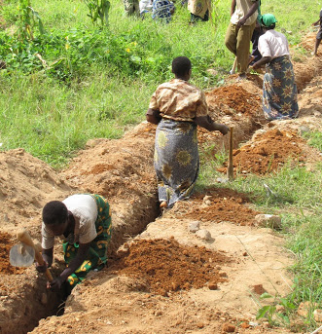
Community equity is required for every project because it is an indicator of investment that directly correlates to ensuring long-term sustainability. Only after the community’s investment is confirmed, during the community development activities and infrastructure construction, WMI will bring water treatment equipment to the community for installation.
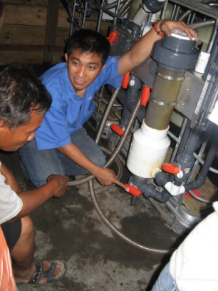
There are opportunities in every project for the community to invest. The time commitment made by the SWC and volunteer WASH promoters to train and ready community members are leading investments of equity. Other equity investment opportunities are specific to communities depending on project needs and available skills and assets. Examples of community equity include supplying materials for construction, financial investment, and the provision of skilled and unskilled labor support during construction activities.
Installation of Water Treatment Equipment
Once community equity is confirmed, WMI brings in water treatment equipment specifically selected or designed for the community. Operators chosen by the SWC and community members will assist in the installation. Once installed, WMI conducts a detailed operator training, including pump controls, filter backwashing, chlorine disinfection adjustment, residual chlorine level testing and daily operator log documentation. After successful equipment installation, operator training and confirmation of functioning SWC, the water system is commissioned. At this point, safe water flows for the community.
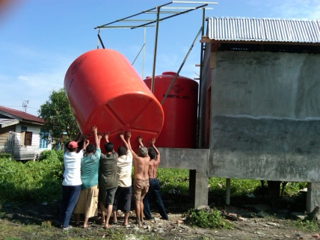
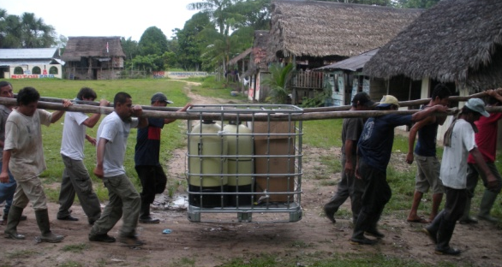
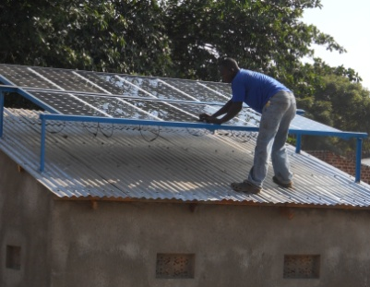
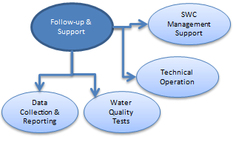
Post Commisioning Follow-Up & Support
Work in the community does not end once a project is commissioned as communities still need support to begin what will be an ongoing operation. WMI provides a minimum of one year of follow-up and support for recipient communities. During this time we monitor the technical operation and verify water quality through physical, chemical and microbiological analysis.
Just as important as the technical operation is the SWC’s leadership. During the follow-up period, we monitor the reliability of the committee, re-engage in additional trainings and track the financial accountability of the project. WMI documents the data collected through our remote monitoring devices and the reporting of our field staff of all technical and social aspects of the project. Logged and stored on WMI’s Reporting Database, this data is vital for measuring performance and developing best practices.
For further detail of complete project activities, an in-depth flow chart can be found at the link below. Please note that no specific time values are represented. A typical project’s implementation period can last three to eighteen months.
http://wiki.watermissions.org/GetFile.aspx?Page=2012-Community-Managed-Model-Documents-and-Forms&File=WMI%20Project%20Flow_Community%20Model_Rev3_013013.pdf
Opportunities for Rotarian Involvement
There are opportunities for volunteer Rotarian involvement in every project. The in-country host Rotary club’s (RC) involvement is desired for identifying communities in need. During implementation, the host RC’s involvement is sought for the initial community mobilization meeting, the leadership WASH awareness meeting and the commissioning ceremony celebration. The host RC’s support is valuable in these specific areas because of its ability to be a positive influence in the community, especially with leadership, in helping to promote the project.
The International RC’s involvement is needed for project monitoring, financial accountability and data reporting. Volunteer opportunities during project implementation will be considered for Rotarians with specific skill sets. Project field visits for Rotarians without specific skill sets can coincide with the commissioning ceremony and/or follow-up visits as they provide an opportunity to evaluate the success of a project.
It is important to understand that there are no specific timetables with any project activity. This is a community-led process which moves according to the community’s pace. This makes it difficult to schedule trips for Rotarian travel, especially internationally. Coordinating an international trip with a project commissioning months in advance is difficult. WMU will not push a commissioning to take place before the community is ready in order to facilitate a Rotarian visit. Likewise, we would not hold off commissioning or delaying safe water, in order to facilitate a Rotarian visit. We are careful not to jeopardize the sustainability of any project, in order to facilitate non-essential volunteer engagement.
Project Budget: : Col. Monterrey Water and Sanitation Project
Phase 1: Assessment $ 4694
Phase 2: Design & Engineering $ 4859
Phase 3: Construction & Installation $ 340,958
Phase 4: Community Development $ 12,369
Phase 5: Follow-up & Support $ 10,807
Total $ 373,687
For more information about our five areas of focus to ensure sustainability and the specifics of this project, please see page 5. Additionally, refer to the attached Project Schedule of Values, Material & Installed Equipment List and Scope & Responsibility Matrix for further detail.
About Water Missions International
Water Missions International is a nonprofit Christian engineering organization providing sustainable safe water and sanitation solutions for people in developing countries and disaster areas. Using state-of-the-art technology and engineering expertise, the organization has provided access to safe water for more than 2.4 million people in 49 countries on five continents since 2001. Water Missions International implements customized solutions through a comprehensive community development model in its ten permanent country programs in Africa, Asia, Latin America and the Caribbean.
Notably, Charity Navigator has awarded Water Missions International their top rating seven years in a row, a distinction shared by only three percent of the charities rated by the organization.
Water Missions International
www.watermissions.org
843.769.7395 (phone) | 866.280.7107 (toll free) | 843.763.6082 (fax)
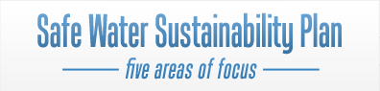
Water Missions International is uniquely positioned as a trusted organization with experienced indigenous engineers and community development staff in the lead. Explore the five areas of focus for sustainability below.
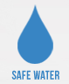
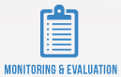
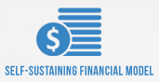
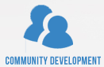
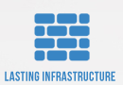
a sustainable safe water solution. This is a safe water project, meaning we meet World Health Organization standards for safe water that is free of all microbiological contaminants. We won’t settle for simply ‘improved’ water, which may still contain these harmful contaminates. This means our treatment technologies implemented in a community must be specific to the individual community’s needs. There is no one-size fits all solution. Water Missions International and Rotarian’s have conducted a preliminary community needs site assessment with a water quality analysis. We anticipate the need for a Chlorine Dousing system, pumping and distribution system.
a sustainable supporting infrastructure plan. Quality matters for projects that need to last, which is why we’re committed to investing in infrastructure. The supporting infrastructure investment must consider life cycle costs. Investing in low quality materials, equipment and inadequate construction in an effort to minimize the initial investment cost (price tag for a project) is not a recipe for sustainability. Inferior equipment and construction quality ultimately increase operating and replacement costs to the community, becoming an obstacle to their success. If we invest well on the front end, we’ll ensure long-term sustainability. The preliminary site assessment for these communities revealed the need for a chlorine dousing system and a pumping system with required electrical components and a permanent enclosure to support the solution. A detailed list of all items can be found in the attached Schedule of Values and Material and Equipment List.
a sustainable community development plan. Equipment and construction are the easy parts of the project. Community development requires considerable investment in the community by Water Missions International’s indigenous staff. By community development, we are referring to the process of engaging community leadership, in order to form and train a Safe Water Committee (SWC). This committee will lead community ownership, project operations and financial management as well as equip and mobilize volunteer leaders in WASH (water, sanitation and hygiene) promotion. Community development also includes training system operators and engaging the entire community in health and hygiene education.
a sustainable financial plan. Like any kind of utility, there will be expenses related to ongoing operation and equipment replacement (depreciation) costs in the future. Addressing these costs, specifically the financial burden placed on the community to maintain their project, is too often overlooked. Water Missions International will equip the Safe Water Committee with financial tools to plan for these future costs. We’ll also work with the SWC to instill the value of safe water in the community and ensure affordability according to World Health Organization standards, as this is an issue of access.
a monitoring and evaluation plan to ensure sustainability. Once a project is commissioned, meaning the safe water is flowing, the need for further community engagement is still required. Water Missions International will continue to monitor both the Safe Water Committee and the technical components of the water projects for a minimum of one year. Follow-through is important to us and vital to ensuring sustainability. We’re committed to seeing projects succeed for those we serve, so we continue to check in with the community after the tap is turned on to ensure that the system is running properly and that they are equipped to operate and sustain their project.

